JAVA
PROJECT

import java.util.Scanner;
public class RooftopSolarEnergyMonitor {
// METHOD 1: Calculates daily energy generated (kWh = kW * hours)
static double calculateEnergy(double power, double hours) {
return power * hours; // Arithmetic operator (*)
}

// METHOD 2: Calculates total cumulative energy using a FOR-EACH loop
static double calculateTotal(double[] energyReadings) {
double total = 0.0;

// FOR-EACH LOOP
for (double singleDayEnergy : energyReadings) {
total += singleDayEnergy; // Arithmetic operator (+=)
}

return total;
}

public static void main(String[] args) {
// SCANNER CLASS
Scanner sc = new Scanner(System.in);

// DATA TYPES (String, int, double, boolean)
String ownerName;
int numberOfDays;
double panelPower;
double totalEnergy;
boolean isSystemActive = true;

System.out.println("=== Rooftop Solar Energy Monitor System ===");

System.out.print("Enter Owner Name: ");
ownerName = sc.nextLine();

System.out.print("Enter Solar Panel Power Rating (in kW): ");
panelPower = sc.nextDouble();

System.out.print("Enter Number of Days to Monitor: ");
numberOfDays = sc.nextInt();

// Array data type to store daily generation
double[] dailyEnergy = new double[numberOfDays];

// FOR LOOP (Used for taking daily readings)
System.out.println("\n--- Enter Sunlight Hours ---");
for (int day = 0; day < numberOfDays; day++) {
System.out.print("Day " + (day + 1) + " Sunlight Hours: ");
double sunlightHours = sc.nextDouble();

// Method call
dailyEnergy[day] = calculateEnergy(panelPower, sunlightHours);
}

// Method call using FOR-EACH LOOP inside calculateTotal()
totalEnergy = calculateTotal(dailyEnergy);

// Display Summary Section
System.out.println("\n=================================");
System.out.println(" SOLAR ENERGY REPORT ");
System.out.println("=================================");
System.out.println("System Owner : " + ownerName);
System.out.println("Panel Capacity: " + panelPower + " kW");

// WHILE LOOP (Used for displaying daily array elements)
System.out.println("\n--- Daily Breakdown ---");
int dayCounter = 0;
while (dayCounter < numberOfDays) {
System.out.println("Day " + (dayCounter + 1) + ": " + dailyEnergy[dayCounter] + " kWh");
dayCounter++; // Arithmetic operator (++)
}

System.out.println("\nTotal Generation: " + totalEnergy + " kWh");

// CONDITIONAL STATEMENTS (if - else if - else ladder)
double benchmarkThreshold = numberOfDays * panelPower * 4.0;

if (totalEnergy >= benchmarkThreshold) {
System.out.println("System Performance Status: Excellent");
} else if (totalEnergy >= (benchmarkThreshold - 10.0)) { // Arithmetic operator (-)
System.out.println("System Performance Status: Good / Average");
} else {
System.out.println("System Performance Status: Needs Inspection (Low Efficiency)");
}

// DO-WHILE LOOP (Used to keep menu active)
int menuChoice;
do {
System.out.println("\n--- Interactive Menu Options ---");
System.out.println("1. Show Total Generation Summary");
System.out.println("2. Calculate Average Daily Output");
System.out.println("3. Exit Program");
System.out.print("Select an option (1-3): ");
menuChoice = sc.nextInt();

// SWITCH CASE (Used for menu selection)
switch (menuChoice) {
case 1:
System.out.println("Result: Total Energy generated over " + numberOfDays + " day(s) is " + totalEnergy + " kWh.");
break;

case 2:
double averageEnergy = totalEnergy / numberOfDays; // Arithmetic operator (/)
System.out.println("Result: Average Daily Generation is " + averageEnergy + " kWh/day.");
break;

case 3:
System.out.println("Exiting Rooftop Solar Monitor. Thank you!");
isSystemActive = false;
break;

default:
System.out.println("Invalid Selection! Please choose 1, 2, or 3.");
break;
}

} while (menuChoice != 3 && isSystemActive);

sc.close();
}

}

OUTPUT
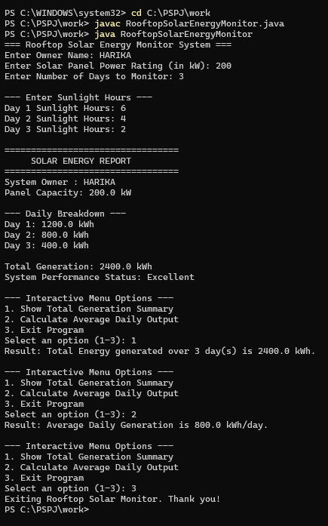

ABSTRACT
With the growing adoption of renewable energy, monitoring solar power generation is essential for optimizing system performance and tracking efficiency. This project presents a console-based Rooftop Solar Energy Monitor application developed in Java as part of the 1st-year PSPJ curriculum. The system allows users to track daily solar power generation by taking input for panel capacity and sunlight hours, providing real-time yield reports, performance status evaluations, and average output statistics.
The application serves as a comprehensive demonstration of core structured Java concepts. User interactions and data inputs are handled using the Scanner class, stored across primitive and reference data types (String, int, double, boolean, double array), and computed using fundamental arithmetic operators (*, /, +, -, +=, ++). The system incorporates all major control flow and iteration structures: a for loop for daily data entry, a while loop to display breakdown records, a for-each loop for calculating total generation inside a modular static method, and a do-while loop paired with a switch statement to drive an interactive navigation menu. System efficiency is evaluated dynamically using an if-else if-else conditional ladder. This project illustrates how fundamental Java concepts can be seamlessly combined into a single cohesive program to address practical engineering problems.

ADVANTAGES OF THE ROOFTOP SOLAR ENERGY MONITOR

- Comprehensive Educational Coverage The project incorporates every core Java programming concept required for 1st-year PSPJ, including the Scanner class, multiple data types, arithmetic operators, all four loop structures (for, while, for-each, do-while), conditional statements (if-else), switch-case branching, and modular static methods.
- Modular and Scalable Design By separating computation into dedicated static methods like calculateEnergy() and calculateTotal(), the code remains clean, easy to read, and reusable. New features can be added in the future without breaking existing functionality.
- Dynamic Data Handling Instead of hardcoding values, the program utilizes array data structures and dynamic user inputs to handle any number of days, panel capacities, or sunlight hours entered by the user.
- Interactive User Experience The inclusion of a do-while loop paired with a switch-case menu allows users to continuously view totals, calculate averages, or exit the program without having to restart the application each time.
- Automated Performance Insights The application does not just compute raw numbers; it evaluates system efficiency against benchmark thresholds and alerts the user whether solar generation is Excellent, Good, or Needs Inspection.
- Real-World Practical Utility The program addresses a genuine real-world problem in renewable energy management by automating daily yield tracking and providing immediate performance analysis for rooftop solar panel owners.

CONCLUSION

In conclusion, the Rooftop Solar Energy Monitor project successfully shows how basic Java concepts can be used to solve a practical, real-world energy tracking problem. By combining essential 1st-year programming tools—such as the Scanner class, data types, arithmetic operators, loops, conditional logic, switch cases, and static methods—the application creates a simple yet useful tool for monitoring solar panel performance. Overall, this project helped build a strong foundation in structured Java programming, code organization, and logic building for future software development.

FUTURE WORKS

- Add a Graphical Interface (GUI) In the future, we can build a simple visual desktop window with buttons and charts instead of running it in the terminal.
- Save Data in Files or Database We can add file saving (like TXT or Excel files) so daily data isn't lost when the program closes.
- Calculate Money Saved We can add logic to calculate electricity bill savings based on total units (kWh) generated.
- Smart Error Handling We can add simple checks to prevent the program from crashing if a user types letters instead of numbers.

THANK YOU

